* 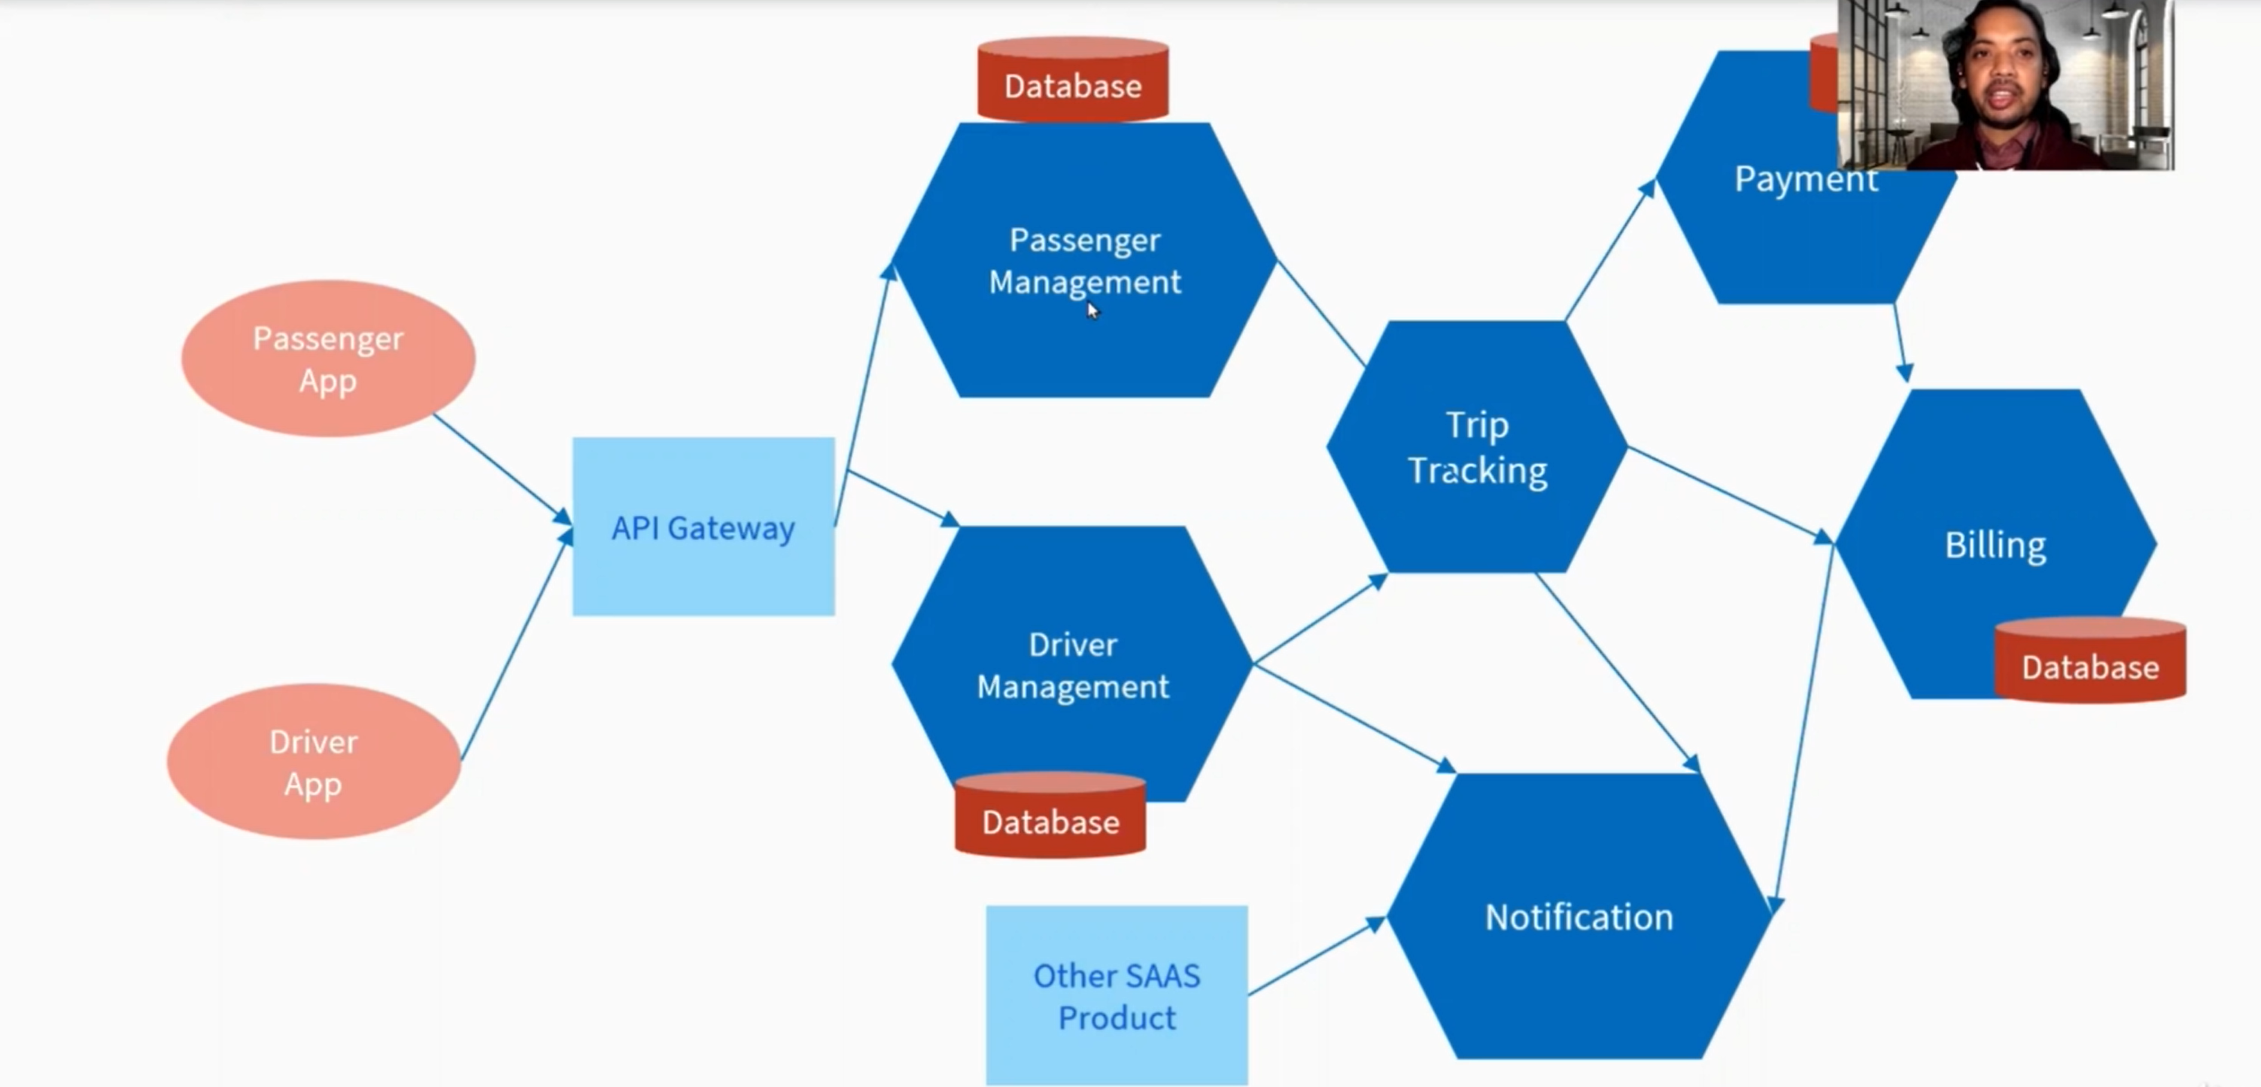
* All modules are loosely coupled in microservice architecture.
* In microservice architecture each module is independent micro application which can be design, develop, test and deploy independently on same and/or different servers.
* All module talks to each other over a network using technology like REST API.
* Each module can have their own database.
* If any module or instance went down then other services will not be going down.
* Scaling of each microservice can be done independently.
* Its loose coupled in case of design, development, test, deploy as well as monitoring.
* We can use same and/or different technology stack for each microservice.
* We can create independent CI/CD pipeline for each micro services.